Education Guide for the Danish Higher Education System
Education Opportunities for Asylum Seekers and Refugees in Denmark
2016

Social Science across Borders
The Syrian Cultural Institute in Denmark
By Buthaina Shaheen

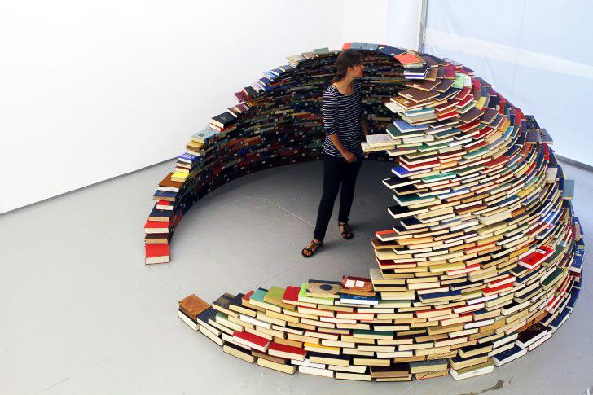

Preface
This guide emerges from an idea that a group of academics have conceptualized around the need to democratise the right of education for refugees and asylum seekers. This group is called Social Science across Borders (SSAB) and includes Mikkel Flyverbom, Christiana Berg Johansen, Cecilie Glerup, Jan Pet Khorto, Emil Husted, Nicol Foulkes Savinetti, Marion Chen and Buthaina Shaheen.

With guidance and consultation with the members of SSAB, Buthaina Shaheen has written this guide.

This guide has been initiated by SSAB, and developed by the Syrian Cultural Institute in Denmark by Buthaina Shaheen. This version is edited by Sune Haugbølle, who is a member of the Institute’s board.

We really hope, that this guide would be beneficial for people aspiring to continue their studies in Denmark.

Table of Contents
Introduction 4
The status concerning higher education opportunity and education for asylum seekers 5
Refugee status and higher education 6
An overview of the education system and higher education system in Denmark 7
Higher education Institutions in Denmark 10
1- Business Academies (Erhversakademi). 11
2. University Colleges (Professionshøjskoler). 12
3- Maritime educational institutions. 13
4- Higher Education Institutions within the Fine Arts. 14
5- Universities. 15
University study programmes 15
6- Adult and continuing higher education 18
Grading System for education in Denmark 20
Assessment and recognition of foreign educational qualifications in Denmark – (Guide to education qualification recognition) – Admission requirements 21
Foreign qualifications for entry to higher education in Denmark 21
General entry requirements 21
Specific entry requirements 22
Language requirements 22
Documentation requirements 23
Translation of documents 24
Conditions for receiving an assessment 24
Degrees in the Danish Higher Education System 24
How and when to apply (optagelse) 26
Guidance for Education (Counseling and guidance by mentors) 26
Regional guidance centres (Studievalg) 26
The seven regional guidance centres. 27
eGuidance 27
National Guidance Portal 28
SU (the Danish students’ Grants and Loans Scheme) 28
SU as a foreign citizen 29
Applying for equal status for the first time 29
Contact SU offices 29
Empirical work with refugees and asylum seekers regarding higher education opportunities 30
Frequently asked questions. 30
Informal Education 35
Kiron 35
Kiron’s Education Model. 35
Study Tracks at Kiron (Kiron’s Study Programmes). 36
Applying to study at Kiron 36
Student Services 36
Contacts 37

Introduction

This education guide offers general information about the higher education system in Denmark. It opens by explaining what the status of being an asylum seeker or refugee means to having the right to study at higher education institutions. It also visualizes the education system in Denmark generally.

Specifically, this guide deals with a number of topics, mainly: 1) it provides a description of different educational institutions in Denmark, 2) the Danish grading system, 3) the assessment and recognition of foreign documentations, 4) Danish degrees, 5) applying for a study programme, 6) guidance for education, and 7) the Danish students’ Grants and Loans Scheme (SU). Moreover, this guide offers some empirical work in the form of listing some questions made by Syrian refugees residing in Denmark, as well as a link to a questionnaire on higher education and asylum seekers and refugees. Finally, this guide mentions a way to an informal education within higher education. Kiron, an open higher education institution, is the example listed in this guide.

The status concerning higher education opportunity and education for asylum seekers

According to the current education policy in Denmark, asylum seekers are not allowed to pursue higher education programmes as long as their cases are still being processed.

The Danish Immigration Service is responsible for the education of asylum seekers.
It requires that newly asylum seekers participate in an introductory course, which introduces them to Danish language, culture and society. When asylum seekers’ application is to be proceeded in Denmark, s/he is required to participate in courses in Danish, English or in her/his native language. If s/he is granted asylum, intensive Danish language course will be offered until relocation to the assigned municipality is in place.

Asylum seekers over eighteen years, whose application has not received a final rejection are required to participate in courses, which aim at increasing asylum seekers’ trade or professional skills. These courses are held at asylum centres or with them.

Asylum seekers are entitled to carry out a paid or unpaid internship.
To read more about the asylum seeker’s education opportunities, please click her:
https://www.nyidanmark.dk/en-us/coming_to_dk/asylum/conditions_for_asylum_applicants/education_and_other_activities.htm

While the Danish Immigration Office’s task is to make a decision concerning granting or rejecting asylum, the Danish Red Cross runs asylum camps and is in charge in providing information to asylum seekers about their education opportunities. Therefore, at the Red Cross adult education schools, asylum seekers are offered language courses in Danish and English, as well as lessons in Social Studies and CV writing. To learn more click here:
https://www.rodekors.dk/det-goer-vi/roede-kors-asyl/what-we-do-in-the-asylum-department/adult-education-and-work-experience

Refugee status and higher education

Most refugees move out of the camps to their municipality one month after being granted asylum. Refugees and family-reunified individuals are offered, under the integration bill, a three-year integration contract. This includes courses in Danish language, culture and society, as well as internship opportunities, which would pave the way to obtain a job. To know more, click here (only in Danish): http://dengodemodtagelse.dk/integrationsindsatser/copy_of_test/kommune

While you are under the three-year integration contract, where the focus is primarily on Danish language courses and internships, you can consider investigating your education opportunities within the higher education system.

Higher Education opportunities for refugees in Denmark

Refugees are granted the same rights as Danish citizens when it comes to education. Higher education in Denmark is free for refugees who receive a “ temporary residence permit that can be upgraded to a permanent one (midlertidig opholdstilladelse mmf (med mulighed for) varigt ophold)”. Please check your residence card to find out whether you are entitled to free education or not. Read more: http://studyindenmark.dk/study-options/tuition-fees-scholarships.

The term “higher educational programme” is normally used when the admission into the education programme requires that one has completed upper secondary school or the equivalent. This means that if a refugee in Denmark wishes to enrol in higher educational programmes, s/he must have completed her/his upper secondary school and must carry a certificate from the country s/he has obtained from.

An overview of the education system and higher education system in Denmark

Refugees who wish to enrol in higher education programmes might find it helpful to have an idea of how the education system as a whole is structured in Denmark. In this case, one can compare it with the education system in the country one lived in previously. The following table shows how the Danish education system looks like:
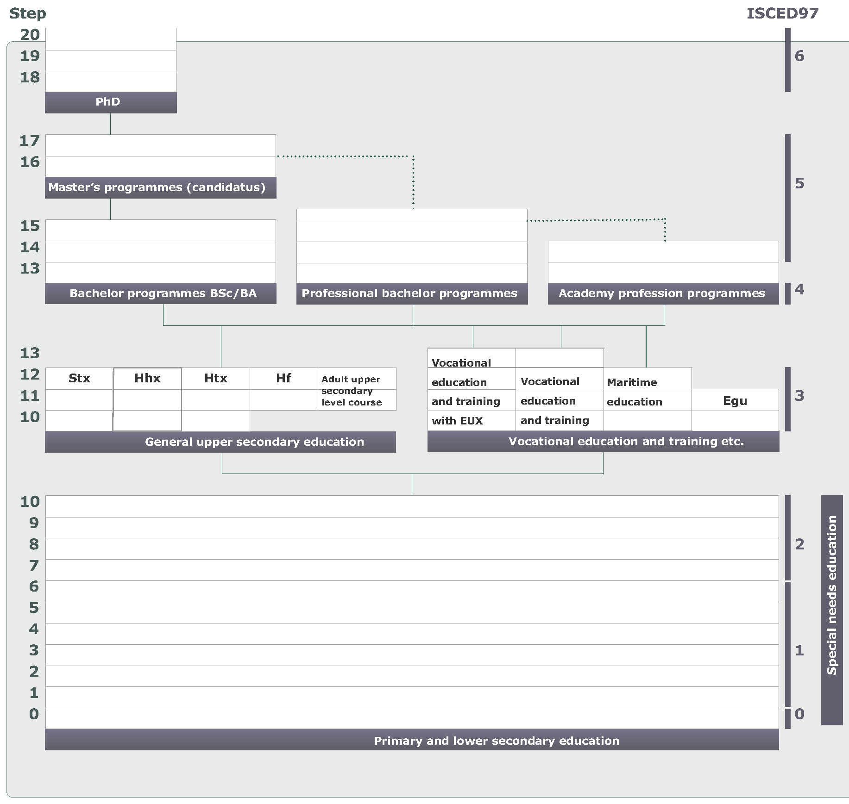
Source: the Ministry of Higher Education and Science – Denmark

The table above shows that a person can pursue a higher education programme if s/he has completed a general upper secondary education or a vocational education and training.

To get more information of the Danish education system in general from the Ministry of Higher Education and Science, please click on the link below. You can for instance read about: principles for education in Denmark; general organisation and administration; primary and lower secondary education; upper secondary education.
http://ufm.dk/en/education-and-institutions/the-danish-education-system/overview

Also, the following table shows how the mainstream education system is structured compared to other types of education. The first column from the left side of the table -in light green – is the higher education and it includes the upper sub- columns respectively; Bachelor, Master and PhD; Professional Bachelor; and academic profession.

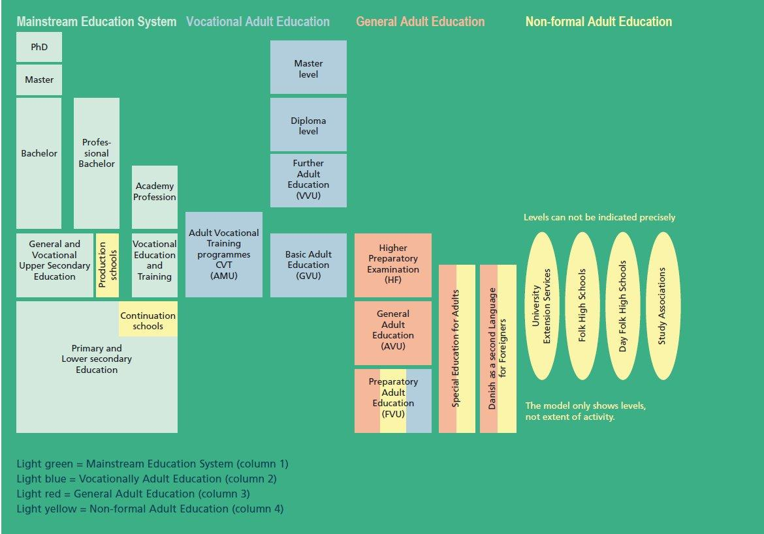

Source: the Ministry of Higher Education and Science – Denmark

The following table offers the structure of the higher education system in Danish language:
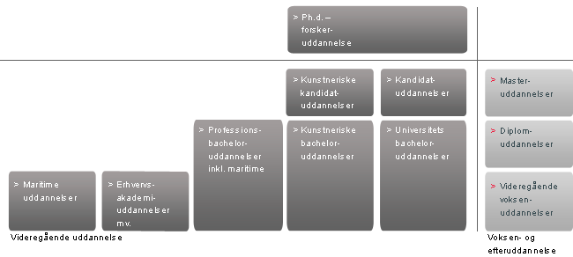
Source: the Ministry of Higher Education and Science – Denmark

The table reads from the right: First column is videregående voksen uddannelser (higher education for adults), Diplom uddannelser (Diploma education); Master uddannelser (Master education). Then to the left of them, the bottom row reads: Universitets bachelor-uddannelser (university bachelor education); kunstneriske bachelor-uddannelser (artistic bachelor education); professions bachelor uddannelser inkl. martime (professional bachelor including maritime); erhvervs akademi uddannelser mv.; Profession academy education, and maritime uddannelser (maritime education). The next row reads; kandidat uddannelser (Master’s education) and kunstneriske kandidat uddannelser (artistic education). The last row reads Ph.d. forsker uddannelse (Ph.d. research education).

Higher education Institutions in Denmark

As shown above, the higher education system includes Bachelor programmes BSc/BA, Master’s programmes (candidatus) and PhD; Professional Bachelor programmes; and academy profession programmes. They are taught at higher education institutions including universities, university colleges, and academies of professional higher education.
Higher education is offered by six types of higher education institutions. They include:
- Business Academies (Erhversakademi)
- University Colleges (Professionshøjskoler)
- Maritime Educational Institutions.
- Higher education Institutions within the Fine Arts
- Universities
- Adults and continuing higher education.
Below is a brief description of each institution, as well as useful links, where you can read further.

1- Business Academies (Erhversakademi).

There are nine independent business academies that offer academy profession programmes and further education related to these in different parts of Denmark. They include:
- The Copenhagen School of Design and Technology
- Zealand Institute of Business and Technology
- Danish Academy of Business and Technology
- IBA International Business Academy
- Lillebaelt Academy
- Copenhagen Business Academy
- EA Business Academy South West
- Business Academy of higher education Mid West (in Danish)
- Business academy Aarhus.
To learn more about these nice institutions, please click here:
- University Colleges (Professionshøjskoler).

Academies profession programmes

They are awarded usually after two years and they are equivalent to the first two years of a bachelor degree. They are focused on specific professions or job functions.
There are approximately twenty seven academy profession programmes and exit in the following fields: Information technology, Business and Economics, Technology, Laboratory technology, Social sciences, Design and Healthcare.
To learn more about the academies profession programmes, please click here:
http://ufm.dk/en/education-and-institutions/higher-education/business-academies-1/academy-profession-programmes

Admission requirements

Access requirements are general upper secondary education or relevant vocational education and training, supplemented by adequate general upper secondary courses (e.g. maths, physics, English).

2. University Colleges (Professionshøjskoler).

There are seven university colleges in Denmark that offer and develop higher education with a strong relation to practice on an international professional level. University colleges offer higher education programmes such as bachelor programmes and diploma programmes. Graduates find employment in the public sector as teachers, nurses, social workers. Also, programmes in fields such as information technology, engineering, business and media are aiming at the private sector.
They university colleges include:

- Metropolitan University College
- University College Copenhagen
- University College of Northern Denmark
- University College South Denmark
- University College Lillebaelt
- University College Zealand
- VIA University College

To learn more about these seven university colleges, please click here, where you can also visit the homepage of the university colleges:
http://ufm.dk/en/education-and-institutions/higher-education/university-colleges/about-the-university-colleges

Professional bachelor programmes

They are awarded usually after three to four and a half years and they correspond to that of university bachelor programmes, but with a stronger focus on professional practice.
There are approximately 85 professional programmes and exit in the following fields: Healthcare, Pedagogy, Business and Economics, Information technology, Technology, Media and communication, Social sciences and Design.
To learn more about the professional bachelor programmes, please click here:
http://ufm.dk/en/education-and-institutions/higher-education/university-colleges/university-college-educations
https://www.ug.dk/programmes/universityprogrammes/bachelordegreeprogrammes

Admission requirements

Access requirements are general upper secondary school leaving examination or comparable qualifications. It might also have specific requirements such as a particular subject combination in secondary school or certain level of grades

3- Maritime educational institutions.

Relevant institutions include:
- Engineering Colleges for Engine Officers.
- Maritime and Education Centre for Engine Officers and Able Ratings.
- Maritime and Education Centre for Ship’s Officers.
- Nautical College and Skipper School.
- School and Sailing Training Vessels for Ordinary Ratings.
- School for Commercial Fishermen.
To learn more about these institutions, please click here:
http://ufm.dk/en/education-and-institutions/higher-education/maritime-education-institutions/about-the-maritime-institutions

Maritime education programmes

The maritime education programmes offer education programmes for the Danish merchant fleet and the fishing industry. You can become a ship’s officer, shipmaster, marine and technical engineer, ship machinist and commercial fisher, among others.
To learn more about the education programmes, please click here:
http://ufm.dk/en/education-and-institutions/higher-education/maritime-education-institutions/maritime-educations

Training

If interested in taking such an education, you can have the opportunity to train in shipping companies such as Maersk. The following link shows a complete list of shipping companies and what training they offer:
http://ufm.dk/en/education-and-institutions/higher-education/maritime-education-institutions/maritime-educations/shipping-companies
Also, you can have a look at the training record books such as “ship’s machinist”, “marine engineer” and others through this link:
http://ufm.dk/en/education-and-institutions/higher-education/maritime-education-institutions/maritime-educations/training-record-books.

4- Higher Education Institutions within the Fine Arts.

There are four education institutions that offer higher educations within the Fine Arts. They include:
- The Royal Danish Academy of Fine Arts, Schools of Architecture, Design and Conservation.
- The Royal School of Library and Information Science
- Aarhus School of Architecture
- Kolding School of Design
To learn about these institutions, please click here:
http://ufm.dk/en/education-and-institutions/higher-education/creative-higher-education-institutions/about-the-institutions.

Education programmes

The proscribed duration of study is between four and six years. Programmes are located at the national institutions of education and are offered in areas of:
- Fine arts.
- Classical and rhythmic music
- Film
- Theatre and dance.
To read more about the artistic programmes and their policy, please click here:
http://kum.dk/servicemenu/english/policy-areas/education/

Requirements:
Students are required to show their artistic talents through an admission test before getting accepted.

5- Universities.
There are eight universities in Denmark. They are research-based higher education at Bachelor, Master’s and PhD level. Universities are responsible for the majority of all public research in Denmark. They must also participate in the exchange of knowledge and skills within society. Universities in Denmark are:
- University of Copenhagen
- Aarhus University
- University of Southern Denmark
- Roskilde University
- Aalborg University
- Technical University of Denmark
- Copenhagen Business School
- IT University of Copenhagen.
To learn about these universities, please click here:
http://ufm.dk/en/education-and-institutions/higher-education/danish-universities/the-universities-in-denmark

University study programmes

Bachelor’s degrees and Master’s degrees and PhD degrees cover academic disciplines such as social sciences, humanities, natural science, health science, technical science and theology. In the following, there is a short explanation of the three degrees:

University Bachelor’s degree

It is warded after a three-year undergraduate programme and undertaken within one or two subject areas. For example, one can combine two study disciplines such as communication and psychology or business and cultural studies. In order to learn more about this, one can click the above link and read about Bachelor’s and Master’s programmes and the subject one can combine. Bachelor’s degree qualifies students for occupational functions and for postgraduate studies (Master’s degree)

Many degree programmes are offered in English. By clicking on the following link, you can read about the “Programme Subject Area (fields)” offered on a Bachelor level such as: Fine Arts Programmes; Humanities Programmes; Natural Science Programmes: Social Science and Economic Programmes; and Technical and Technological Programmes:
https://www.ug.dk/programmes/universityprogrammes/bachelordegreeprogrammes

Requirements for undergraduate studies
- Upper secondary school certificate. Please click here to read more about it: http://studyindenmark.dk/study-options/admission-requirements
- Proof of proficiency in English.
- Some study programmes have addition requirements such as: Subjects passed on a certain level ( A, B or C) or with a certain minimum grade as well as passed admission test or interview. Please click here to learn more: http://studyindenmark.dk/study-options/admission-requirements.

Master’s degree (candidatus degree- Kandidatdgrad)

It is usually awarded after two years of study following a Bachelor’s degree undertaken within one or two subject areas. For example, one can combine two study disciplines such as communication and psychology or business and cultural studies. In order to learn more about this, click the above link and read about Master’s programmes and the subject one can combine. This degree qualifies students for a professional career and scientific work such as admission to a PhD programme.

Requirements for postgraduate studies

- A Bachelor’s degree recognised internationally.
- English language proficiency proof or proficiency in Danish, depending on the language of the study programme.

Master’s, Bachelor’s and Academy Profession study programmes

In this section you will find more than 700 degree programmes and 1300 courses taught in English. Click on the following link in order to read about them and find the programme you are best interested in:
http://studyindenmark.dk/portal

PhD
Moreover, as for PhD, all Danish universities offer a PhD programme within their research areas. To learn more about PhD in Denmark, please click here:
http://ufm.dk/en/education-and-institutions/higher-education/danish-universities/phd-programme

PhD and research
The duration of a Danish PhD is programme is usually three years. The PhD programme is and independent research under supervision, where the completion of a PhD thesis is submitted in the end. Danish universities offer PhD programmes and courses. Please read more about PhD and research by clicking on the following link:
http://studyindenmark.dk/study-options/find-your-international-study-programme/phd-research

PhD position
Danish PhD scholarships are fully funded. Some PhD programmes are developed in partnerships between private companies and universities. To read about current PhD positions and the universities offering them, please click here:
http://studyindenmark.dk/study-options/find-your-international-study-programme/phd-positions-1

Admission requirements
General access requires an Upper Secondary School Certificate or comparable qualifications for the Bachelor programmes. Other some particular programmes require entrance examination or submission of artistic work. Admission to a Master's degree programmes requires the completion of a bachelor's degree.

Generally a Master’s/Candidatus degree is required. However, in some areas, a four-year PhD programme can be offered after the completion of a Bachelor’s qualification and one year of study at postgraduate level.

Degree titles

A Bachelor degree has the title of (BA) in (field of study). A Master’s degree has the title of (MA) in (field of study) in English, but in Danish has a different title: cand. I (field of study). Please click on the following link for more information:

http://ufm.dk/en/education-and-institutions/higher-education/danish-universities/university-study-programmes/copy_of_the-university-bachelor2019s-degree-and-the-candidatus-master2019s-degree

A PhD degree is PhD I (field of Study).

6- Adult and continuing higher education
Under this category, one can enrol in the following:

Academy profession degree (akademiuddannesle).
Programmes prepare students to assume occupational functions, as well as give them access to relevant diploma programmes. This degree is awarded after 2 years of part-time study or 1 year full-time study.

Admission requirements.
Upper secondary education or higher is required, as well as at least two years of relevant work experience.
To read more and get in touch with a person in charge, please click here:
http://ufm.dk/en/education-and-institutions/higher-education/adult-and-continuing-education/further-adult-education

Diploma programmes
Diploma programmes prepares students to assume highly qualified occupation functions, as well as give them access to master programmes. This degree is awarded after two years of part-time study.
Upper secondary education or higher is required, as well as at least two years of relevant work experience.
To read more and get in touch with a person in charge, please click here:
http://ufm.dk/en/education-and-institutions/higher-education/adult-and-continuing-education/further-adult-education

Master degree (mastergrad).
The master degree is a research-based degree at university level. This degree is awarded after two years of part-time and offered by the eight Danish research universities. This degree is tuition fee-based.
Disciplines for this education include IT and technology, pedagogy, design, language and communication, management and organisation, among others.

Admission requirements.
Relevant educational qualification at bachelor’s level or higher, as well as at least two years of relevant work experience are required.
To read more and get in touch with a person in charge, please click here:

http://ufm.dk/en/education-and-institutions/higher-education/adult-and-continuing-education/further-adult-education

Grading System for education in Denmark
The following table gives an overview of the present 7-point grading scale, which has been in effect sine 2007. It shows also the old 00 to 13 grading scale.

Grade | Description | ECTS | Old scale (00-13)
12 | For an excellent performance displaying a high level of command of  all aspects of the relevant material, with no or only a few minor weaknesses | A | 13  11
10 | For a very good performance displaying a high level of command of  most aspects of the relevant material, with only minor weaknesses | B | 10
7 | For a good performance displaying good command of the relevant material  but also some weaknesses | C | 9  8
4 | For a fair performance displaying some command of the relevant material  but also some major weaknesses | D | 7
02 | For a performance meeting only the minimum requirements for acceptance | E | 6
00 | For a performance which does not meet the minimum requirements  for acceptance | Fx | 5  03
-3 | For a performance which is unacceptable in all respects | F | 00

It is also worth-mentioning that pass/fail assessment is also used in higher education.
To learn more about the grading system in Denmark, please click here:
http://ufm.dk/en/education-and-institutions/the-danish-education-system/grading-system
To learn more about the grading system of Danish higher education, please click here: http://ufm.dk/en/education-and-institutions/the-danish-education-system/grading-system/karakterer_videregaaende_en.pdf

Assessment and recognition of foreign educational qualifications in Denmark – (Guide to education qualification recognition) – Admission requirements
You are eligible for admission to Danish higher education if your qualifications are recognized as being comparable to Danish entrance qualifications. .

In order to pursue your study in Denmark, your educational degree (s) or educational qualifications have to be assessed and recognised in Denmark. It is the Danish Agency for Higher Education, which provides such an assessments of foreign qualifications.
By clicking on the following link, you can read more about the agency, access its contact: address, telephone and email:
http://ufm.dk/en/the-minister-and-the-ministry/organisation/danish-agency-for-higher-education

The assessment of your education documents by the Danish Agency of Higher education serves as a guideline. Each educational institution in Denmark is responsible for its own admissions. This means that all your education documents have to be assessed by the Agency, in addition to that it is up to the educational institutions to put forward their own requirements for your admission. The institution will require certified copies of your educational qualifications. It means you should provide the intuitions with “copies with original stamps and signatures, or have two people who are not related to you sign the back of the copy with their name, address and birth date. Some institutions require that they receive the documents directly from the issuing institution”.

Foreign qualifications for entry to higher education in Denmark
In order to be able to apply for admission to higher education in Denmark, you have to fulfil three types of requirements:

General entry requirements
If you possess an upper secondary school certificate from the country where you have obtained it, by clicking on the link below list you can check if you are eligible for entry into Danish higher education. This table enclosed in the link shows the minimum requirements for admission to Danish higher education, i.e the upper secondary school certificate with their names from a number of countries. Above this secondary school requirement, the applicant is furthermore required to document at least B level in English and Danish C level in Mathematics.
http://ufm.dk/en/education-and-institutions/recognition-and-transparency/find-assessments/entry-to-higher-education
If that is not sufficient and does not answer you question, you can contact the institution to which you wish to apply or the Danish Agency for Higher Education. In this case, you need to get an assessment of your non-Danish qualification by filling in application form, which you find in the following link:
http://ufm.dk/en/education-and-institutions/recognition-and-transparency/get-assessment

Specific entry requirements
One must meet the specific entry requirements, which include the level of the subjects passed the grades obtained in each subject and the overall average of grades. Please click here to read more:
http://ufm.dk/en/education-and-institutions/recognition-and-transparency/recognition-guide/admission-he

Language requirements
English and Danish proficiency may apply. If you wish to study high education in Danish, this requires that you have passed the Study Test in Danish (see below under Danish language requirements). If you wish to study in English, you must submit proof of English proficiency equivalent to English B (see below under English language requirements) level in Denmark. Please read more about the language requirement in the following link:
http://ufm.dk/en/education-and-institutions/recognition-and-transparency/recognition-guide/admission-he

Danish language requirements
Education programmes require one of the following Danish tests: “Danish as a Foreign Lanuage” (“Studieprøven i dansk som andetsprog”), “Danish Test2” (“Danskprøve 2”) or “Danish Test 3” (“Danskprøve 3”). In you wish to review degree programmes offered Danish, please click here:
https://www.ug.dk

English language requirements

English language tests such as TOEFL, IELTS and Cambridge ESOL are usually used. The score equivalent is determined by the educational institutions. An estimate of the ranges you can expect is:

IELTS* | TOEFL* | Cambridge Advanced English*
English B - test score of at least 6.5 points | English B - test scores in the ranges of 550-583 (paper-based), or 213-237 (computer-based test), or 79-93 (internet-based test) | English B - Certificate in Advanced English (CAE)
English A - test score of at least 7.0 points | English A - test scores in the ranges of 587-610 (paper-based), or 240-253 (computer-based test), or 94-101 (internet-based test) | English A – Certificate of Proficiency (CPE)

*Note: click on IETS, TOEFL and Cambridge Advanced English, in order to access their website.
Please click on the following link to read more:
http://studyindenmark.dk/study-options/admission-requirements

You can contact the institution’s International Admission Office, if you can document English proficiency at an equivalent level. The office can determine if your English level is sufficient

Documentation requirements
Besides the application form (mentioned above) which you have to fill out in order to submit to the Danish Agency for Higher education, your education documents – upper school, Bachelor, Master, Diploma etc. – must be also be enclosed.
This link shows which education documents you have precisely to enclose:
http://ufm.dk/en/education-and-institutions/recognition-and-transparency/get-assessment/documentation-requirements

Translation of documents
Documents in English, French, German, Swedish, Norwegian and Spanish require no translation. Documents in other languages must be translated into Danish or one the above-mentioned languages. To read about where you can send your documents for translation, please click here:
http://ufm.dk/en/education-and-institutions/recognition-and-transparency/get-assessment/translation

Conditions for receiving an assessment

The Danish Agency for Higher education offer assessment of qualification at all educational levels, however the qualification must be recognised in the country of education and must belong to the formal education system of that country. Please read more by clicking here:
http://ufm.dk/en/education-and-institutions/recognition-and-transparency/get-assessment/conditions

Degrees in the Danish Higher Education System
Degrees in the Danish higher education system range between an academy profession degree, Bachelor’s degree (professional or within arts) Master’s degree, to PhD degree, as shown in the table below. Degrees are measured in ECTS credits, which is acronym for European Credit Transfer System. ECTS is used throughout higher education institutions in Europe as it facilities the comparison of study programmes and course. To learn more it ECTS credits, please click here:
http://www.studyineurope.eu/ects-system
The following table shows an overview over the qualification levels, the ETCS credits, and the degree cycles for the Danish higher education:
Danish qualifications levels | Ordinary higher education degrees | Adult/continuing higher education degrees | Qualifications Framework for the European Higher Education Area – Bologna Framework | European/National Qualifications Framework for Lifelong Learning – EQF/NQF
Academy Profession level | Academy Profession (AP) degree (90-150 ECTS) | Academy Profession (AP) degree (60 ECTS) (also known as Further Adult Education (VVU) degree) | Short cycle | Level 5
Bachelor’s level | Professional Bachelor’s degree (180-270 ECTS) | Diploma degree (60 ECTS) | First cycle | Level 6
 | Bachelor’s degree (within the arts) (180 ECTS)
 | Bachelor’s degree (180 ECTS)
Master’s level | Master’s degree (within the arts) (120-180 ECTS) | Master degree (60-90 ECTS) | Second cycle | Level 7
 | Master’s degree (120 ECTS)
PhD level | PhD degree (180 ECTS) |  | Third cycle | Level 8

Source: Ministry of Higher Education and Science

60 ECTS correspond to one-year full-time study while 30 ECTS correspond to one semester full-time study. Courses at higher education are offered within two semesters each year: Autumn and spring semesters.

In order to read more about the qualification levels, the ETCS credits, and the degree cycles for the Danish higher education, please click on the following link:

http://ufm.dk/en/education-and-institutions/recognition-and-transparency/transparency-tools/europass/diploma-supplement/standardbeskrivelse-danish-higher-education-system.pdf

How and when to apply (optagelse)

The admission deadline for undergraduate studies is 15 March for courses starting in August or September. However, few institutions take applications in January or February with deadline as 1 September. You can access application forms two months prior to deadline. Please click here to fine them: http://www.optagelse.dk/admission/index.html?

The links below are useful if you wish to read more about applying through optagelse.dk
http://studyindenmark.dk/study-options/applying-to-undergraduate-programmes-in-denmark-eu-eaa-1

Guidance for Education (Counseling and guidance by mentors)

In Denmark, it is the Ministry of Higher Education and Science (uddanneses- og Forskningsministeriet) that is responsible for offering guidance in relation to your education in the higher education institutions.
The Danish guidance system consists of various elements. One of them is concerned with the regional guidance centres, which are responsible in providing guidance for people who wish to enter a higher education programme. There are 7 regional guidance centres (Studievalg) (please see the following section). Another element is eGuidance that can be reached by e-mail, phone, chat or text message all week long and morning and evening (see below). Also, there is the national guidance portal: www.ug.dk, where you can find information about education, training and careers.

Regional guidance centres (Studievalg)

There are seven regional guidance centres (Studievalg) in Denmark. They are listed below with their perspective links. You can visit the centres in order to get information about the higher education opportunities. You can also make an appointment for a guidance session. Meetings with guidance counsellors can take place at different neutral localities located across the seven regions such as public library.

The seven regional guidance centres.

This section offers the names of the guidance centres. When you click on the centres’ links, you can access contact details of the centres such as telephone numbers; addresses, emails, as well as you can access other information about education programmes, application deadlines and how to make an appointment, among others.
- Studievalg København. https://www.ug.dk/studievalg/studievalgkbh/english

- Studievalg Sjælland. https://www.ug.dk/studievalg/studievalgsjaelland/english

- Studievalg Fyn. https://www.ug.dk/studievalg/studievalgfyn-forside/

- Studievalg Nordjylland. https://www.ug.dk/studievalg/studievalgnordjylland/english

- Studievalg Østjylland. https://www.ug.dk/studievalg/studievalgoestjylland/english

- Studievalg Midtog Vestjylland. https://www.ug.dk/studievalg/studievalgmidtvestjylland/english

- Studievalg Sydjylland. https://www.ug.dk/studievalg/studievalgsydjylland/english

Studievalg København – a Regional Guidance Center
This session offers a case story of one the seven regional guidance centres, solely Studievalg København. By clicking on the following link, you can read the whole case story of guidance for higher education that Studievalg København offers (page 12, 13):
http://ufm.dk/en/publications/2014/files-2014-1/guidance_in_education_pdfa.pdf

eGuidance

eGuidance provides individual guidance about education and employment to you via chat, telephone, text message, email which you can access by clicking on links concerning the seven regions above. The Facebook address for the eGuidance is:

https://www.facebook.com/eVejledning . eGuidance can be contacted during days, evenings and on weekends. To read more about eGuidance, please click on the following link (page 14,15):
http://ufm.dk/en/publications/2014/files-2014-1/guidance_in_education_pdfa.pdf

National Guidance Portal
The national guidance portal www.ug.dk provides people with information to enable them make decisions about their education, training and careers.
By clicking on this link, you can read about what information this portal provides you with (page: 16):
http://ufm.dk/en/publications/2014/files-2014-1/guidance_in_education_pdfa.pdf
Guidance in Higher Education
You can find guidance in the course of Academy Profession Programmes and Professional Bachelor Programmes, as well as at the Danish Universities. Please click on the following link in order to read about the education guidance the higher education offers (page:17, 18). http://ufm.dk/en/publications/2014/files-2014-1/guidance_in_education_pdfa.pdf

SU (the Danish students’ Grants and Loans Scheme)

When you enrol at the higher education institutions, you can receive SU (Statens Uddannelsesstøtte) SU - the Danish students' Grants and Loans Scheme.
As a refugee, you have the right for SU. However, it depends on what kind of refugee status you have received, i.e. those who receive “protection status” are therefore at required to pay tuition fees at the Danish higher education, are not entitled for SU. Please click here to read more: (http://studyindenmark.dk/study-options/tuition-fees-scholarships).

SU as a foreign citizen

Non-Danish citizens must fulfil special conditions to be placed on an equal footing with Danish citizens and receive SU. In the following link, you can read about the equal status according to Danish rules:
http://www.su.dk/english/su-as-a-foreign-citizen/equal-status-according-to-danish-rules/.
One of the equal status is “You fall within Section 2(2) or (3) of the Act on Integration of Aliens in Denmark”, where you can read that you can apply for SU if you fall within the previously mentioned sections. Please click here: http://www.su.dk/english/su-as-a-foreign-citizen/equal-status-according-to-danish-rules/you-fall-within-section-2-2-or-3-of-the-act-on-integration-of-aliens-in-denmark/

To read more about 2(2) or (3) of the Act on Integration of Aliens in Denmark, please click here:
https://www.nyidanmark.dk/NR/rdonlyres/105C4108-2914-4BCB-B5CE-5023B5EF62F7/0/act_on_integration_2005.pdf

Applying for equal status for the first time

If you fall within within Section 2(2) or (3) of the Act on Integration of Aliens in Denmark”, you can apply for equal status for the first time. Click here to read how to apply for the first time: http://www.su.dk/english/su-as-a-foreign-citizen/how-to-apply-for-the-first-time/

Contact SU offices

If you have questions regarding SU, you can contact SU administrative offices at the educational institutions. Please click here to find the institution you are looking for (only in Danish):
http://www.su.dk/kontakt/kontakt-du-laeser-i-danmark/su-kontorerne-paa-uddannelsesstederne/

Empirical work with refugees and asylum seekers regarding higher education opportunities

empirical work is two-fold: fieldwork with refugees and asylum seekers where we listen to their questions regarding higher education; as well as a questionnaire which we spread as widely as possible in order to get as much information as possible about refugees and asylum seekers’ situation regarding higher education. Please fill in our questionnaire here: https://docs.google.com/forms/d/1II4JzqHkfhq07wCDY6ixh1qj5JYajjxKSELgmGL5IKU/edit

As far as our direct contact with refugees and asylum seekers is concerned, we have adapted semi-structured questions where we asked general questions concerning higher education and have included questions and comments from refugees and asylum seekers.

In the following session, we have listed the questions we have received from refugees and asylum seekers and have searched for answers.

Frequently asked questions.

Do refugees with temporary protected status have the right for higher education?
Firstly, it is worth noting that in “temporary protected status”, an asylum seeker is granted a residence permit for a maximum of one year and after three years for a maximum of two years at a time. Read more here: https://www.nyidanmark.dk/en-us/coming_to_dk/asylum/asylum.htm.

These kinds of questions can be directed to the Danish Agency for Higher Education (Styrelsen for Videregående Uddannelser) under the auspices of the Danish Ministry of Higher Education and Science. Please click her to access the agency’s homepage, where you find, among others, its contact details. You can just call the agency up directly at: +45 7231 7800
http://studyindenmark.dk/about-us

You can even write them on facebook page:
https://www.facebook.com/studyindk/

Questions concerning studying in Denmark can be generally found on the official page of http://studyindenmark.dk/
This page is administrated by the Agency for Higher Education: http://studyindenmark.dk/about-us

Under tuitions fees, you can find the answer to the above-mentioned question.
It is only individuals with permanent residence or a limited residence with consideration for permanent residence (varigt ophold), have access to study in Denmark without tuition fees. Refugees who have been granted only a temporary residence have the opportunity to apply to study at Danish higher education, however, they have to pay tuition fees.
Please click here to read more: http://studyindenmark.dk/study-options/tuition-fees-scholarships
On the same page, you can find scholarships opportunities, please pay attention to the criteria of eligibility.

However, students can obtain a grant from the state i.e. and therefore they do not have to pay if the study programmes are within:
- The vocational higher education programmes - Business Academies (erhvervsakademiuddannelser ) and University Colleges (professionsbacheloruddannelser). This appears in the act 35 paragraph 1, number 1-4, which was endorsed in October 2014.
- University education programmes are found in Act § 2, stk. 4, nr. 1-5 in order (bekendtgørelsen) nr. 598 of 8. Marts 2015 about grants and audits at universities.
- The higher education artistic programmes are found in § 2, nr. 1-4, in the order (bekendtgørelsen) nr. 407 of 5. May 2009. This is about the demand to charge tuition fees from foreign students who wish to study at the Ministry of Culture’s education programmes.
The above-mentioned information has been obtained through contacting the Danish Agency for Higher Education (Styrelsen for Videregående Uddannelser). The above is a translation of our communication with them, and the following is their original answer is Danish.
Jeg vil gerne henlede jeres opmærksomhed på hjemmesiden studyindenmark.dk, hvoraf en stor del spørgsmål om det at studere i Danmark er besvaret, herunder f.eks. spørgsmål i forhold til betaling af deltagerbetaling (tuition fees) http://studyindenmark.dk/study-options/tuition-fees-scholarships

Som det fremgår af hjemmesiden er det alene personer, der har en permanent opholdstilladelse eller en tidsbegrænset opholdstilladelse med henblik på varigt ophold, der har adgang til at studere uden deltagerbetaling. Flygtninge, der alene har fået midlertidigt ophold har mulighed for at søge om optagelse på en dansk videregående uddannelse, men de vil skulle betale deltagerbetaling.

Reglerne om, hvilke studerende der kan udløse tilskud fra staten, og som derfor ikke skal betale, kan for så vidt angår:
- de erhvervsrettede videregående uddannelser (erhvervsakademiuddannelser og professionsbacheloruddannelser) findes i LEP-lovens § 35, stk. 1, nr. 1-4, jf. lovbekendtgørelse nr. 1147 af 23. oktober 2014,
- universitetsuddannelserne findes i § 2, stk. 4, nr. 1-5, i bekendtgørelse nr. 598 af 8. marts 2015 om tilskud og revision m.v. ved universiteterne,
- de videregående kunstneriske uddannelser findes i § 2, nr. 1-4, i bekendtgørelse nr. 407 af 5. maj 2009 om opkrævning af betaling fra udenlandske studerende på Kulturministeriets videregående uddannelser (denne bekendtgørelse omfatter også de videregående kunstneriske uddannelser under Uddannelses- og Forskningsministeriet).

Med venlig hilsen

Mark Neumann
________________________________
Mark Neumann
Specialkonsulent
Center for Jura
Direkte telefon.: + 45 7231 8662
E-mail: mane@uds.dk
Uddannelses- og Forskningsministeriet
Styrelsen for Videregående Uddannelser Bredgade 43 DK-1260 København K
Telefon: +45 7231 7800 Fax: +45 7231 7801
E-mail: ufm@ufm.dk
www.ufm.dk

We find no match between the titles of the education degrees we have obtained in our home countries and the Danish higher education system. For example in Syria, there are education institutions called “intermediate institutes” (Ma’ahid Mutawasita), where studies last for three years and becomes for instance “engineer assistant”.
In Denmark there are no such “intermediate institutes” as those in Syria. However, one can obtain a higher education degree where study programmes last for two years such as in the case of Business Academies (Erhversakademi). Please click here to learn more about this educational institution: To learn more about these Business Academies and its education programmes, please click here:
http://ufm.dk/en/education-and-institutions/higher-education/business-academies-1/about-the-academies
http://ufm.dk/en/education-and-institutions/higher-education/business-academies-1/academy-profession-programmes
The other educational institution where you can find study programmes that last between three and four years or more are university colleges (Professionshøjskoler). Please click here to read more about university colleges and their educational programmes:
http://ufm.dk/en/education-and-institutions/higher-education/university-colleges/about-the-university-colleges
http://ufm.dk/en/education-and-institutions/higher-education/university-colleges/university-college-educations
https://www.ug.dk/programmes/universityprogrammes/bachelordegreeprogrammes

The names of the education degree we have obtained in our home country are different from the ones in Denmark.

You can read about the different education programmes and degrees and find out how the names might be similar. Usually when you have gotten your education documents assessed by the Danish Agency for Higher Education, you get to know the name of your education in Danish.

Do I receive SU, when I study in the Higher Education Institutions in Denmark?
This depends on your refugee status. If you have been granted a temporary residence permit that can be upgraded to a permanent one (midlertidlig opholdstilladelse mmf varigt ophold), you can study with no tuition fees. This also implies that you have got the right for SU. Please click here to read more: http://studyindenmark.dk/study-options/tuition-fees-scholarships
https://www.nyidanmark.dk/en-us/coming_to_dk/asylum/asylum.htm

Informal Education

If a refugee or asylum seeker cannot study at the formal higher education institutions, an option would be to choose the informal higher education. The latter implies the unrecognized higher education institutions, such as Kiron.

Kiron

Kiron is an open higher education institution for refugees and asylum seekers only. Kiron’s vision is to provide refugees and asylum seekers with the opportunity to graduate with an accredited and free of charge university degree. Please click here to read about Kiron:
https://kiron.ngo/about

Kiron’s Education Model.

Kiron’s study programme is structured in two stages (online and offline):

- Students participate in two years of online study, wherever they are and according to their own schedule. (online stage)
- Thereafter and when students’ residence status has been finalised, they can complete their degree at Kiron’s accredited partner universities. (offline stage).
To get more insight about these two ways, please click here:
https://kiron.ngo/about/challenge-solution

Massive Open Online Courses (MOOCS).
Kiron selects MOOCS that meets the European Higher Education Quality Standards and customise them with e-learning technology. It offers also online tutoring and student support. Please read more about MOOCS her:
https://kiron.ngo/study

Accreditation

Kiron secures accredited degrees for its students by partnering with accredited higher education institutions in the whole world. Kiron reaches agreements with universities to recognize certain MOOCS, which count as credit university points. Please read more here:
https://kiron.ngo/study

Kiron Certificates
Kiron provides with certificates, if students who decide to enter the labour market instead of perusing study at a partner university. Please click here to read more:
https://kiron.ngo/study

Study Tracks at Kiron (Kiron’s Study Programmes).

Students can choose between four areas of studies:

- Business & Economics.
- Engineering.
- Computer Science.
- Social Sciences.

To read more about these four areas, please click on this link:
https://kiron.ngo/study/tracks

Applying to study at Kiron

In order to apply to Kiron, you need a proof of your refugee status or asylum status; a sufficient level of English or you can follow the online classes. As well as, you need an Internet access to do your studies.
The deadline for application at Kiron is the 20th of June. And the beginning of the study is July.

To learn more about the required documents, the deadline and the process of application, please click on the following link:
https://kiron.ngo/study/apply-admission

Student Services

Kiron’s student service teams offer supports to students such as, language services; buddy programmes; mentoring programme; psychological services and career services. In order to read more about Kiron’s support, please click here:
https://kiron.ngo/study/student-services

Contacts

If you wish to contact Kiron, please click here:
https://kiron.ngo/contact

If you wish to read more about Kiron, please click on Kiron’s homepage:
https://kiron.ngo

https://www.nyidanmark.dk/en-us/coming_to_dk/asylum/conditions_for_asylum_applicants/education_and_other_activities.htm
http://studyindenmark.dk/study-options/tuition-fees-scholarships
https://www.nyidanmark.dk/en-us/coming_to_dk/studies/post_secondary_education.htm
http://ufm.dk/uddannelse-og-institutioner/videregaende-uddannelse/overblik-over-det-videregaende-uddannelsessystem
http://ufm.dk/en/education-and-institutions/higher-education
http://ufm.dk/en/education-and-institutions/higher-education/business-academies-1/academy-profession-programmes
http://ufm.dk/en/education-and-institutions/higher-education/university-colleges/university-college-educations
http://ufm.dk/en/education-and-institutions/higher-education/creative-higher-education-institutions/creative-higher-education-institutions
http://ufm.dk/en/education-and-institutions/higher-education/danish-universities/university-study-programmes/copy_of_the-university-bachelor2019s-degree-and-the-candidatus-master2019s-degree
http://studyindenmark.dk/study-options/admission-requirements
http://ufm.dk/en/education-and-institutions/higher-education/adult-and-continuing-education/master-degree
http://studyindenmark.dk/study-options/admission-requirements
http://ufm.dk/en/education-and-institutions/recognition-and-transparency/recognition-guide
http://studyindenmark.dk/study-options/admission-requirements
ibid
http://studyindenmark.dk/study-options/admission-requirements
ibid
http://studyindenmark.dk/study-options/admission-requirements
http://ufm.dk/en/publications/2014/files-2014-1/guidance_in_education_pdfa.pdf
ibid.
ibid
ibid. P. 10,11.
http://www.su.dk/english/
http://www.statensnet.dk/pligtarkiv/fremvis.pl?vaerkid=1245&reprid=0&filid=602&iarkiv=1#ikke%20danske (only in Danish).
http://www.su.dk/english/su-as-a-foreign-citizen/
https://kiron.ngo/study/apply-admission
https://kiron.ngo/study

